EE5630 DSP f2020 HW# 4 (ch.5) Due 15:30, 11/19/2020

1. (10%)
2. Show that a stable linear time-invariant system with the system function  has a frequency response of which the magnitude is independent of **. (Hint: You can try to set *z* = *ej* in *H*(*z*). Write *H*(*ej*) in the form of  and find the corresponding *A*(*ej*)…)
3. Show that a stable linear time-invariant system with the following system function , where *b* is a complex number and |*b*|<1, also has a frequency response of constant magnitude.
4. (10%)

The following three things are known about a signal *x*[*n*] with *z*-transform *X*(*z*):

*x*[*n*] is real-valued and minimum phase,

*x*[*n*] is zero outside interval 0≦*n*≦4,

*X*(*z*) has a zero at  and a zero at .

Based on this information, answer the following questions:

1. Is *X*(*z*) rational? Justify your answer.
2. Sketch the complete pole-zero plot of *X*(*z*) and specify its ROC.
3. If *y*[*n*]\**x*[*n*]=**[*n*] and *y*[*n*] is right-sided, sketch the pole-zero plot for *Y*(*z*) and specify its ROC.
4. (10%)

A minimum-phase system with the system function *Hmin*(*z*) has the following property: *Hmin*(*z*) *Hap*(*z*) = *Hlin*(*z*) where *Hap*(*z*) is an all-pass system function and *Hlin*(*z*) is a causal generalized linear-phase system function. Please answer the following problems:

(a) Describe the properties of the pole and zeros of the system functions *Hmin*(*z*), *Hap*(*z*), *Hlin*(*z*), respectively.

(b) Suppose that *Hlin*(*z*) = (1-0.5*z*-1)( 1+8*z*-2)/(1-0.36*z*-2). Find the *Hmin*(*z*) and *Hap*(*z*).

(c) Suppose that *Hlin*(*z*) is a causal linear-phase FIR systemhas an impulse response *h*[*n*] = 0 for *n*<0 and *n*>=8 and *h*[*n*] = -*h*[7-*n*]. The system function has a zero at *z* = 0.8*e-j*/4 and another zero at *z* = 2. What is *Hlin*(*z*)?

1. (10%)

The pole-zero plots below describe six different causal LTI systems.

Answer the following questions about the systems having the above pole-zero plots. In each case, an acceptable answer could be none or all.

1. Which systems are IIR systems?
2. Which systems are FIR systems?
3. Which systems are stable systems?
4. Which systems are minimum-phase systems?
5. Which systems are generalized linear-phase systems?
6. Which systems have |*H*(*ej*)| = constant for all **?
7. Which systems have corresponding causal and stable inverse?
8. Which system has the shortest (least number of nonzero samples) impulse response?
9. Which systems have lowpass frequency response?
10. Which systems have minimum group delay?

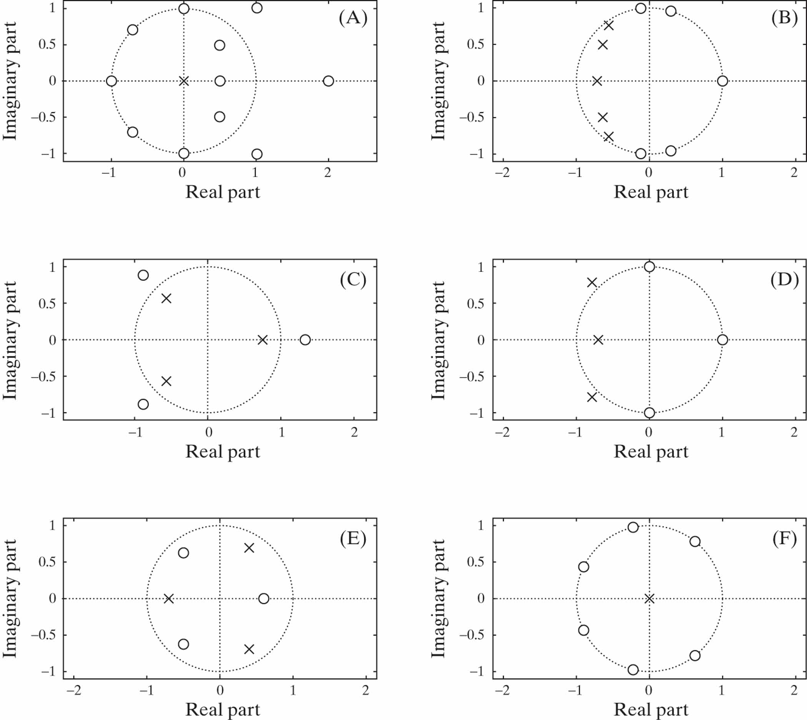

1. (10%)

Let *hlp*[*n*] denote the impulse response of an ideal lowpass filter with unity passband gain and cutoff frequency . Specify whether the following systems are lowpass, highpass, bandpass, bandstop, or multiband filters.



1. (10%)

Let *S*1 be a causal and stable LTI system with impulse response *h*1[*n*] and frequency response *H*1(*ej*). The input *x*[*n*] and output *y*[*n*] for *S*1 are related by the difference equation:

*y*[*n*] – *y*[*n*-1] + 0.25*y*[*n*-2] = *x*[*n*]

1. If an LTI system *S*2 has a frequency response given by *H*2(*ej*) = *H*1(*e-j*), would you characterized *S*2 being a lowpass filter, a bandpass filter, or a highpass filter? Justify your answer.
2. Let *S*3 be a causal LTI system whose frequency response *H*3(*ej*) has the property that *H*3(*ej*)*H*1(*ej*) = 1. Is *H*3(*ej*) a minimum-phase filter? Could *S*3 be classified as one of the four types of FIR filters with generalized linear phase? Justify your answer.
3. Let *S*4 be a stable and noncausal LTI system whose frequency response is *H*4(*ej*) and whose input *x*[*n*] and output *y*[*n*] are related by the difference equation:

*y*[*n*] – **1*y*[*n*-1] + **2*y*[*n*-2] = **0*x*[*n*],

where **1,* *1, and* *0 are all real and nonzero constants. Specify a value for **1, a value for **2, and a value for **0 such that |*H*4(*ej*)| = |*H*1(*ej*)|.

1. (10%)

Consider a causal sequence *x*[*n*] with the z-transform:



For what values of ** is *nx*[*n*]a real, minimum-phase sequence?

1. (10%)

A causal LTI system has the system function



**(a)** Write the difference equation that is satisfied by the input and the output of the system.

**(b)** Plot the pole-zero diagram and indicate the ROC for the system function.

**(c)** Sketch | *H*(*ej*)|*.*

**(d)** State whether the following are true or false about the system:

(i) The system is stable.

(ii) The impulse response approaches a constant for large *n.*

(iii) The magnitude of the frequency response has a peak at approximately ** = ± **/4*.*

(iv) The system has a stable and causal inverse.

1. (10%)

The system function *H* (*z*)of a causal LTI system has the pole-zero configuration shown in Figure below. It is also known that *H*(*z*) *=* 6 when *z* = 1.



(a) Determine *H*(*z*)*.*

(b) Determine the impulse response *h*[*n*]of the system.

(c) Determine the response of the system to the following input signals:

(i) *x*[*n*] *= u*[*n*] *–* 0.5*u*[*n* - 1]

(ii) The sequence *x*[*n*]obtained from sampling the continuous-time signal

*x*(*t*)= 50 + l0cos 20*t* + 30 cos 40*t*

at a sampling frequency *s* = 2* (*40) rad/s.

1. (10%)

Each of the pole-zero plots below, together with the specification of the ROC, describes an LTI system with system function *H*(z)*.* In each case, determine whether any of the following statements are true. Justify your answer with a brief statement or a counterexample.

(a) The system is a zero-phase or a generalized linear-phase system.

(b) The system has a stable inverse *Hi*(z)*.*

